WISDOM ADVENTURES:
EXPLORING THE DHARMA IN BHUTAN
March 4 – March 12, 2017

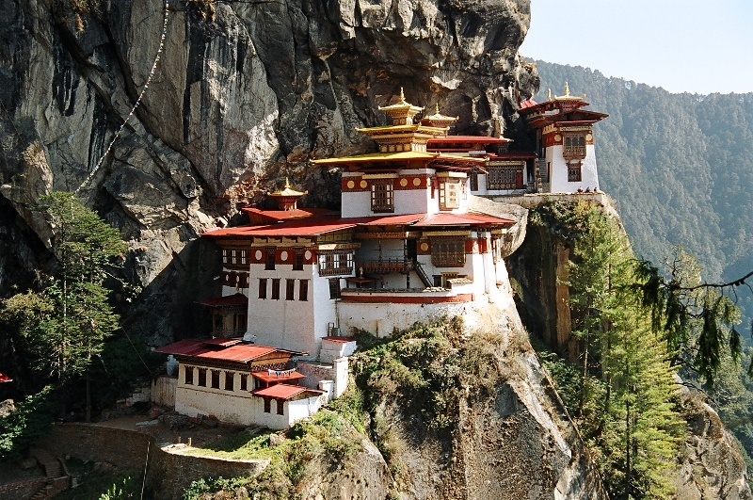

Dzongs—Tsechu festivals—Guided Meditations
Lamas—Monasteries—Stupas—Himalayas
Gross National Happiness—Buddhism & Dharma
Welcome to Ponte Travels!
Join us for a very special journey to Bhutan, the Kingdom of the Thunder Dragon, with renowned spiritual teachers Joel and Michelle Levey—founders of Wisdom at Work. Walk around the stupas, meditate in gorgeous monasteries, unravel the stories in the sacred Buddhist paintings and enjoy a Buddhist festival in Punakha – a colorful and meaningful blend of traditional dance and prayer.

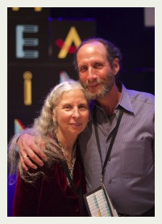

Joel and Michelle Levey have spent the last 45 years bringing the fruits of inner spiritual practices, backed by scientific inquiry, to organizations and communities across the world. They have published numerous books on their work, most recently Mindfulness, Meditation and Mind Fitness, Conari Press (April 2015).

In particular, Michelle and Joel have studied closely with many remarkable teachers in the foundational mindfulness traditions, including The Dalai Lama, Kalu Rinpoche, 16th Karmapa, Zong Rinpoche along with many others.

Nobel Laureate, the Dalai Lama, an advisor on a number of the Leveys’ projects once wrote in a letter to the Leveys: “You are presently engaged in work that has great prospects for bringing the Dharma (the inner sciences of human transformation) to a very wide section of people who may not under ordinary circumstances come into contact with these teaching. I am very pleased about the work that you are doing and send you blessings and prayers for your success.”

Joel and Michelle will call upon their work as “mindfulness pioneers”, the deep knowledge they have of the traditions that underlie Buddhism in Tibet and their dedication to sharing this knowledge with others to lead a profoundly meaningful journey to Bhutan.

More information about the Leveys is available at http://www.wisdomatwork.com.

How is Ponte Travels different from other travel agencies and tour operators?
Unlike travel agencies, we specialize in off-the-beaten path, custom-designed itineraries for individuals and small groups. Our focus is on sustainable tourism, with low environmental impact and high cultural interaction.

24-hour local support & assistance
We partner with expert agents and guides in the countries we visit who are specially trained to deal
with unexpected issues and can assist you 24/7 in the event of an emergency.

Safe and reliable cars & drivers:
Your safety is our primary concern, which is why we only work with partners who share our high safety and quality standards for the drivers and vehicles used.

Hotels:
All our hotels, homestays, guesthouses, eco-lodges, tented camps and houseboats (based on location and itinerary) have been selected to offer a high level of unique experience, service, cleanliness and value.

Local guides:
We use English-speaking, certified, local guides who are passionate about sharing their country with you.

Giving back:
We believe that responsible tourism involves giving back to organizations that are working to improve the lives of the poorest citizens in the countries we visit. We make a donation from every tour to carefully selected NGOs who we believe are making a difference. Learn more about who we support at www.pontetravels.com.

YOUR PERSONAL TRAVEL CONSULTANTS
MARTA RABINS HEATHER MURCHISON
marta@pontetravels.com heather@pontetravels.com

As the Co-founders and Managing Director of Ponte Travels, it’s our personal mission to partner with you to ensure that your entire travel experience is rewarding, enriching and as carefree as possible.

We look forward to hearing from you after you’ve had the chance to review the attached itinerary.

ITINERARY

Day 1: PARO—THIMPU
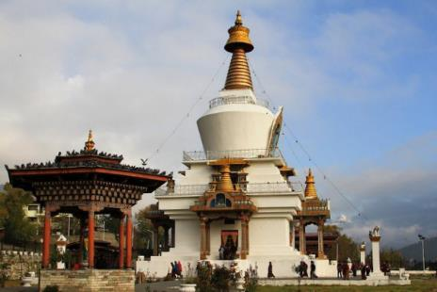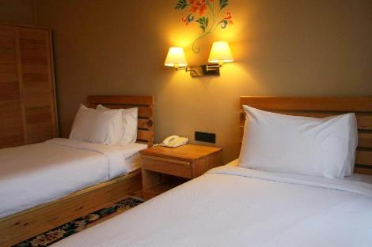
Upon arrival in Paro, transfer to Thimpu, the capital city of Bhutan, approximately an hour by road.

Throughout Bhutan we will encounter three types of religious structures: dzongs (monasteries that are also fortresses, which may also function as government seats), lhakhangs (monasteries or temples) and chortens (stupas or Buddhist shrines).

Afternoon visit to the National Memorial Chorten. Built for the 3rd King of Bhutan, this white and gold stupa is dedicated to World Peace. In the evenings, many locals walk around the stupa, offering prayers and garnering good karma.

Evening session at the hotel after dinner.

Overnight: Hotel Pedling or similar (3 star)
Meals: B, L, D
Altitude: 2,250 m / 7,382 ft

Day 2: THIMPU—TANGO LHAKHANG
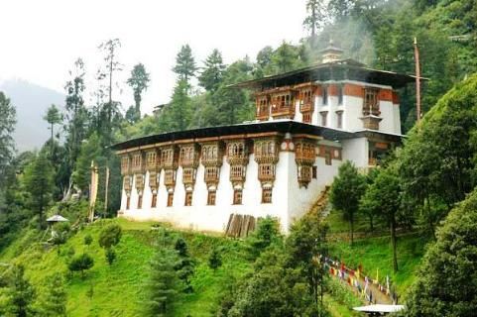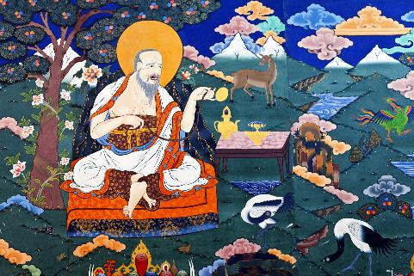
Today, hike to Tango Lhakhang, considered to be a very auspicious site—the unifier of Bhutan was said to have meditated in the nearby caves. Participate in a prayer ceremony with a lama from the monastery who will share his insights on Bhutanese Buddhism, its practices and philosophy with us. Afterwards, meditate at either Tango or Cheri Monastery.

Enjoy a local, organic picnic lunch on our way back to Thimpu.

Afternoon at leisure. Visit a local café, browse for spectacularly colorful Bhutanese postage stamps or outfit yourself as the locals do with a beautiful handwoven gho (for men) or kira (for women).

This evening, dine with a representative from the Center for Bhutanese Study who will talk to the group about Gross National Happiness.

Overnight: Hotel Pedling or similar (3 star)
Meals: B, L, D

Day 3: THIMPU—BUDDHIST HIGHLIGHTS
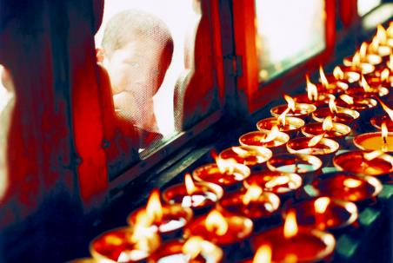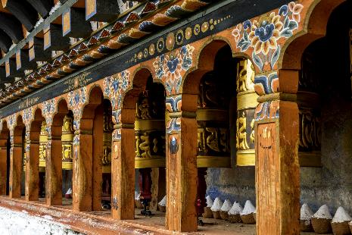
Today we explore Buddha Point – site of one of the largest statues of the Buddha in the world. Afterwards, we’ll have a spiritual session at Zilukha Nunnery—the largest nunnery in Bhutan. We’ll light 108 butter lamps to bring all beings good karma, health and happiness.

After lunch in a local restaurant we’ll visit the Folk Heritage Museum, housed inside a 19th century traditional Bhutanese house and filled with artifacts representing the traditional Bhutanese way of life. Then on to Taschichho Dzong, set along the Wangchhu river and the current seat of the Bhutanese government.

Evening spiritual session after dinner.

Overnight: Hotel Pedling or similar (3 star)
Meals: B, L, D

Day 4: THIMPU—PUNAKHA
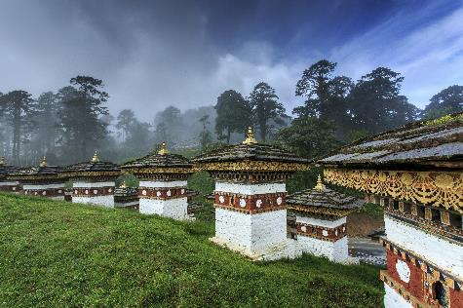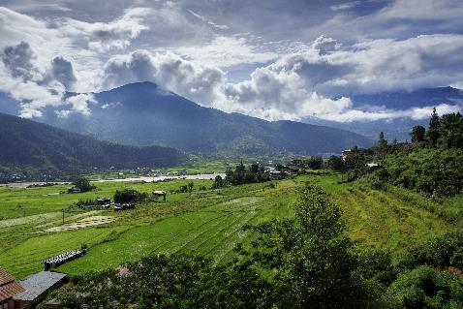
Depart for Punakha Valley. Along the way, stop at Dochula pass, a beautiful site that features 108 stupas. Walk around the stupas, hoist prayer flags and perform a smoke offering to the Mountain gods. Weather permitting, take in the spectacular views of the peaks from the pass and pause for a brief session or dharma talk.

Stop enroute at Chimi Lhakhang or the Devine Mad Monk Temple. A short hike through farm fields takes us to the shrine, where we offer our prayers, light butter lamps and take blessings from the relics of this 15th century saint Lama Drukpa Kuenley.

Time permitting, we may have a short meditation session at Khuruthang Lhakhang shrine.

Arrive in Punakha and rest before dinner. Evening spiritual session after dinner.

Overnight: Meriphuensuem Resort or similar (3 star)
Meals: B, L, D
Altitude: 1300 m/4265 ft.

Day 5: PUNAKHA
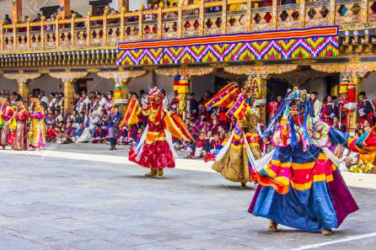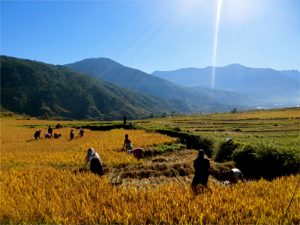
Spend the morning enchanted by the Tsechu Festival. Be cleansed by viewing the festival’s thongdrel–a special thankgka or traditional Bhutanese painting, depicting Padmasambhava, also known as Guru Rimpoche. Enjoy the colorful cham dances performed by masked dancers.

Afternoon spiritual session at the Sangchhen Dorji Lhuendrup Lhakhang Nunnery, where we meditate and discuss what we’ve seen.

Evening dine at a local farm house, with an opportunity to meet and talk with our local village host.
Overnight: Meriphuensuem Resort or similar (3 star)
Meals: B, L, D

Day 6: PUNAKHA—PARO
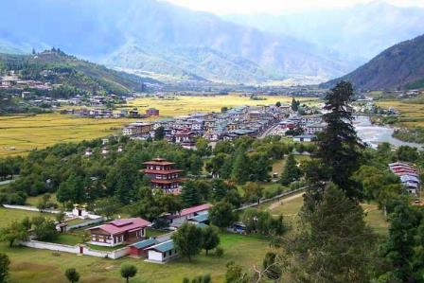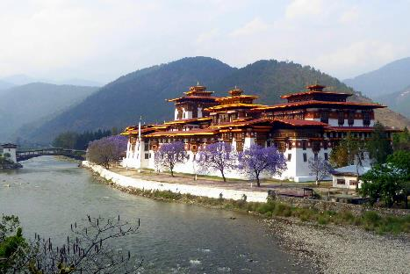
Brief morning meditation before departure. We will make our way back to Paro by road, taking approximately 4 hours, with a stop for lunch on the way.

Upon arrival in Paro, visit Ta Dzong, the Bhutanese National Museum, which holds a fascinating collection of Bhutanse art, including bronze statuary and paintings. We will then walk down the trail to visit Rinpung Dzong, also known as "Fortress of the Heap of Jewels", noted for it’s stunning architecture.

Evening session after dinner.

Overnight: Tenzinling Hotel or similar (3 star)
Meals: B, L, D
Altitude: 2,250 m / 7,382 ft

Day 7: pARO—VILLAGE HIKE
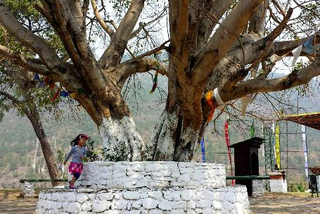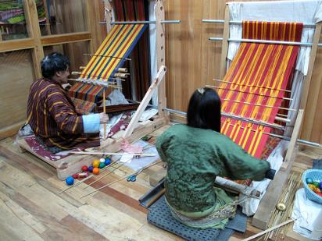
This morning, hike to Dop Shari village, where you will learn more about Bhutanese life. Afternoon free to stroll around Paro and take advantage of some last minute shopping.

Learn about the Bhutanese national sport of archery this evening at the hotel.

Evening spiritual session after dinner.
Overnight: Tenzinling Hotel or similar (3 star)
Meals: B, L, D

Day 8: PARO—TIGER’S NEST
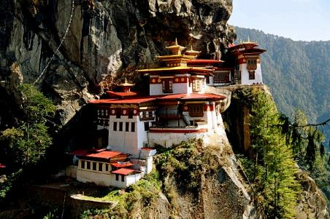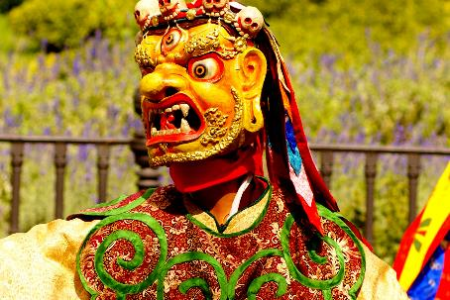
This morning, depart for a half day hike up to the iconic Tiger's Nest monastery. Enjoy the spectacular views from the trail up to the monastery. Lunch after the hike in Paro. Afternoon spiritual session at the hotel to wrap up, followed by a farewell dinner and a cultural show.

Overnight: Tenzinling Hotel or similar (3 star)
Meals: B, L, D

Day 9: PARO—HOME
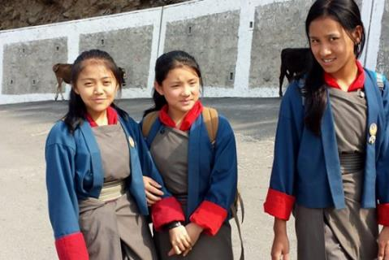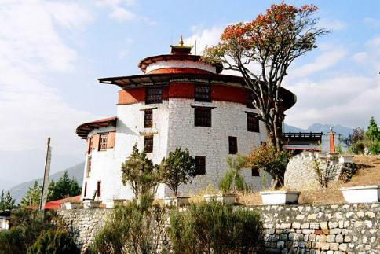
Say goodbye to the friendly people of Bhutan. Transfer to the airport for your flight home.

Meals: B

TOTAL COST OF (9 DAYS, 8 NIGHTS)
(per person, double occupancy): $3890 USD
Single supplement: $440 USD
Airfare economy class Delhi – Paro Round Trip (non-refundable fare): $700

This suggested itinerary can be modified to suit your particular interests and travel time. Contact us with your requests via heather@pontetravels.com, or by calling 206.200.7915

Price Includes:
- All accommodation at the hotels listed or similar
- Meals as indicated in itinerary (Breakfast (B), Lunch (L), Dinner (D))
- Private transportation
- All tours as indicated in itinerary
- Entrance fees
- All excursions with the services of a registered and experienced, English-speaking guide
- Bhutan visa and permits

Not Included:
- International airfare
- Regional airfare
- Airport departure taxes
- Any meals unless mentioned in the itinerary
- Any items of a personal nature, including portage, laundry, telephone calls, table drinks.
- Passport fees
- Gratuities to drivers, guides, wait-staff, maid service, porters
- Optional tours
The cost, hotels and specifics of this itinerary are based on current conditions and are subject to change due to currency fluctuations and unforeseen circumstances at the discretion of Ponte Travels.

MAPS

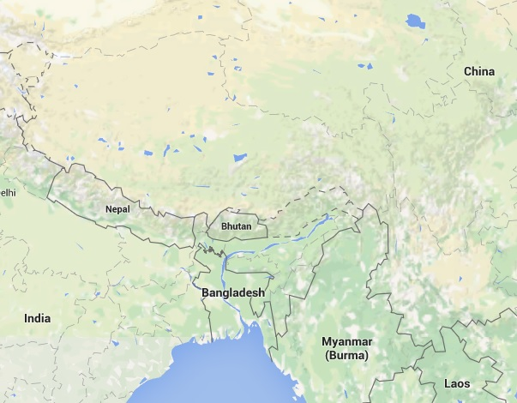

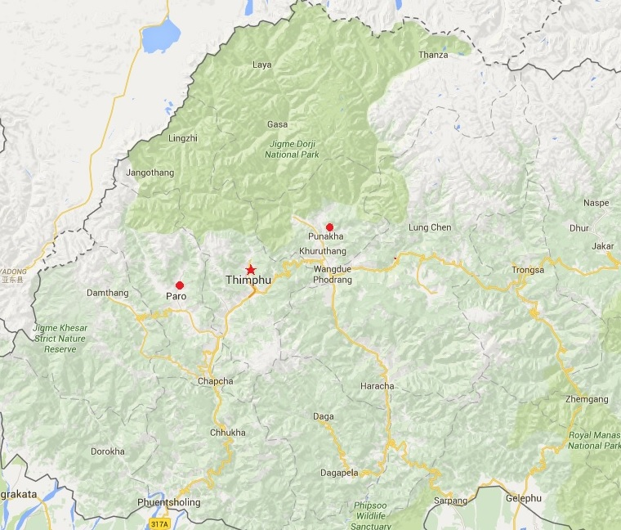

BENEFICIARIES
We believe that to travel responsibly, a portion of our tour cost should benefit the communities we visit. For this trip, our donation will go to a non-profit organization we support that is having a very positive impact around the world: DOCTORS WITHOUT BORDERS— a humanitarian-aid organization that provides ongoing emergency medical aid around the world.
ABOUT PONTE TRAVELS
Ponte Travels specializes in responsible, purposeful travel that works to build personal connections and improve the quality of life in the countries we visit. We create one-of-a-kind journeys for individuals, families and non-profit groups to experience some of the most culturally and wildlife-rich places on earth.

BOOKING AND OTHER INFORMATION

Reservations and Payments: Reservations are initiated on receipt by Ponte Travels of a signed reservation form and a 25% deposit per passenger. The balance of payment is due 90 days prior to departure. If a reservation is made within 90 days of the trip departure, the entire cost of the trip must be paid at the time of confirmation to Ponte Travels. All reservations are automatically canceled if all payments are not received by the due date, with full loss of trip deposit. All payments must be made in US dollars.

Reservation Amendments: All reservation amendments will be subject to changes in cost of the original itinerary and will be subject to the same cancellation penalties described below.

Cancellation and Penalties: All cancellations must be made in writing, signed by the client, and sent to Ponte Travels. All trips are subject to the following, per person cancellation charges based on the number of days before trip departure that we receive your written cancellation request.
- More than 90 days: Forfeit Deposit.
- Less than 90 days: No refund of trip cost.
- No refunds for unused tours or services during your trip.

VISAS
A visa is required of U.S. citizens to visit Bhutan and must be acquired for you by your travel consultant. Your passport must be valid six months from date of arrival with one blank page required for Bhutan.

FINANCIAL PROTECTION
All deposits and tour payments made to Ponte Travels are placed in a trust account until payment is made to suppliers.

TRAVEL INSURANCE
We require that all travelers purchase basic emergency assistance, medical assistance and evacuation insurance when traveling with our groups. We also highly recommend buying additional travel insurance that covers trip cancellation and interruption, lost or stolen baggage, terrorism, natural disasters and more. Travel insurance is available for purchase through Ponte Travels via Travelex. You are also welcome to purchase your own travel insurance.

TO MAKE YOUR RESERVATION, REQUEST A BOOKING FORM BY CONTACTING:

EMAIL: heather@pontetravels.com
PHONE: 206.200.7915
WEB: www.pontetravels.com

